**VINTECH WEBSITE DETAILS**

1. HOME
2. ABOUT US
3. PRODUCTS
4. SERVICES
5. SCHEMES
6. CAREER
7. CONTACT US

HOME PAGE

TOP RIGHT

OFFICE TIMINGS PLEASE SPECIFY

OPEN : - 9:00AM – 6:00PM MONDAY - SATURDAY

RETAINING Business is our middle name

Remove Store Locator

Retain Online Catalogue

Retain Menubar

FOR ALL OFFICE Product – change number – 7200214545

This portion should highlight the product of the month image, tagline,features link should take to schemes page



Make this big in terms of width accommodate full page

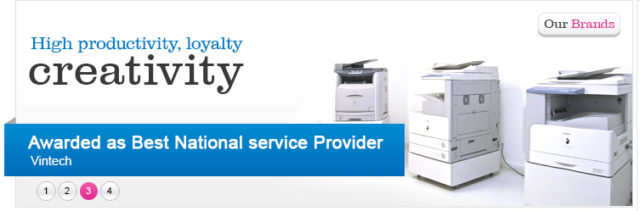

Remove the following

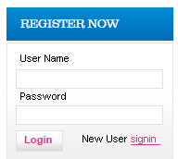

Instead of the above options create following links

1. Log Service Complaint

Clicking this shud take to this form

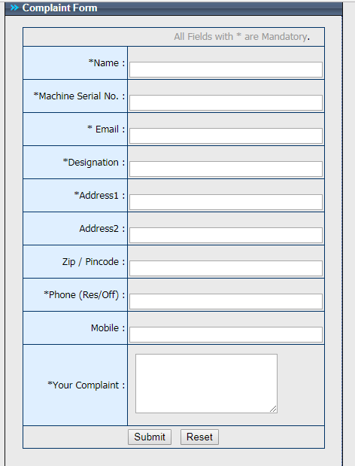

1. Log Tonner Complaint
2. Enquiry Form

Clicking this should to form

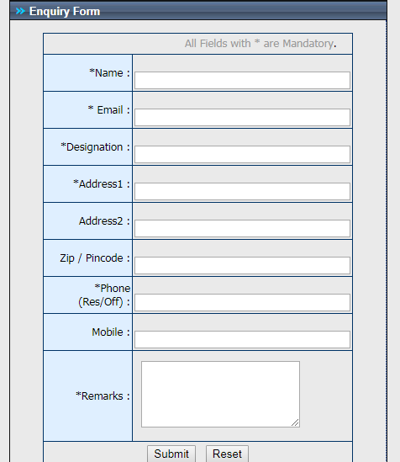

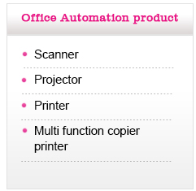

**OFFICE AUTOMATION PRODUCTS**

PRINTERS

MULTIFUNCTIONAL DEVICES

PRODUCTION PRINTERS

WIDE FORMAT PRINTERS

INKJET PRINTERS

DIGITAL DUPLICATORS

Remove

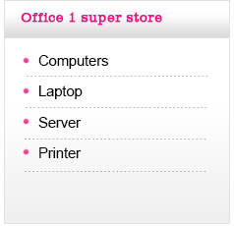

Replace with this options

**SEGMENT WISE PRODUCTS**

CORPORATES

SMB

INSTITUTIONS

 SCHOOLS

HOME

OTHERS

Retain this

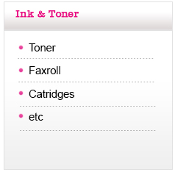

**INK AND TONER**

TONER

CARTRIDGES

ABOUT US PAGE

**Vintech Business Solutions Pvt Ltd**, Outsourced Business Processing organization Successfully handling outsourced business processes like Service Management, Marketing products / services, Inventory management, Receivables Management, Logistics Management for Leading Multinational organizations. Commitment and Consistency in delivering results is a way of life in Vintech for nearing a decade in the very near future.  
  
**Xerox Corporation** is the Key Principle organization for Vintech. Vintech Manages various performance deliveries through dedicated Marketing Team,Service Team, Logistics team and Collection Team administered by able team of Administrators.

SERVICES PAGES

**Vintech Business Solutions Pvt Ltd**, initially evolved as an Authorized service provider for Xerox India Limited in Chennai and continuing as a strong service partner with a consistent commitment to service deliveries expected by Xerox Corporation. 

[**Lacoste Shoes Sale**](http://www.toplacoste.com/)[**tory burch flats**](http://www.shoesretails.com/tory-burch-flats-c-503.html)[**Nike Dunk High**](http://www.nikedunkshow.com/)[**christian louboutin pumps**](http://www.frchristianlouboutin.com/christian-louboutin-pumps-c-3.html)[**tory burch bags**](http://www.shoesretails.com/tory-burch-bags-c-493.html)[**Cheap Air max shoes**](http://www.nikeairmaxsite.com/)[**nike air max 2010**](http://www.nikeairmaxsite.com/nike-air-max-2010-c-45.html)[**air force 1**](http://www.airforce1fashion.com/)[**christian louboutin uk**](http://www.christianlouboutinkick.com/)[**tory burch shoes**](http://www.shoesretails.com/)[**lebron shoes**](http://www.lebronsky.com/)[**Lacoste Shoes 2010**](http://www.toplacoste.com/2010-new-lacoste-mens-shoes-c-22.html)

|  |  |
| --- | --- |
| **»** | Awarded as Best National Service provider by Xerox India Limited. |
| **»** | Team of Service engineers besides professionally trained in the products, they are trained in soft skills like Customer Care Program, Personality Development Module, Self Managed Work Group (SMWG) etc., conducted by Xerox Corporation. |
| **»** | All service personnel are mobile and equipped with Cell phones, Laptops etc, for quick access to customers for the faster response and minimum Downtime in SLA. |
| **»** | Dedicated stores, Logistics facility to cater the supply of spares and consumables. |
| **»** | Dedicated call center to receive customer queries and complaints. |
| **»** | All service process are effectively managed by customized software to have an online MIS for consistent improvement of performance. |
| **»** | SMWG work way in progress for committed, self empowered work force to achieve    greater results through innovative and creative ideas. |
| **»** | Attractive Service contract to cover your Xerox product Have "Piece of Mind" in using Xerox products to the optimum performance and life by availing our following service contracts |

**Various types of AMC (Annual Maintenance Contract) offered by us for Xerox Products.**  
  
**» ASA\***    - Annual Service Agreement- Covers Labour services for a period of one Year.   
**» SSMA\*** - Spares and Service Maintenance Agreement- Covers Spares and Labour for a      period of one Year.  
**»** **FSMA\*** - Full Service Maintenance Agreement- Covers Spares, Labour and Consumable      for a specific period or volume whichever is earlier depending upon the type of product.      Service charges are on Per copy/print basis billed on monthly billing cycle for the      copy/print generated by the customer.  
  
**Note :** Based on the model and type of product, the above said AMCs are offered under the sole discretion of the company.

CONTACT US PAGE

|  |  |
| --- | --- |
| **V** | **Logo change Vintech Business Solutions Pvt Ltd** |
| No:5, 4th Cross Street, | |
| Vijaya Nagar, | |
| Velachery, | |
| Chennai - 600 042. | |
| India | |
|  | |
| |  |  | | --- | --- | | Ph. No.: | +91 - 44 - 42022211 | | Fax : | +91 - 44 - 42022211 | | |
|  | |
|  | |
|  | |
| **Service Call Centre** | |
| |  |  | | --- | --- | | Ph. No.: | +91 - 44 - 42184545 (3 Lines) | | Mail ID : | [**customerservice@vintechbusiness.com**](mailto:customerservice@vintechbusiness.com) | | |
|  | |
| **AMC Toner Supply** | |
| |  |  | | --- | --- | | Ph. No.: | +91 - 44 - 42184400 | | Mail ID : | [**stores@vintechbusiness.com**](mailto:stores@vintechbusiness.com) | | |
|  | |
| **Customer Help Desk** | |
| |  |  | | --- | --- | | Ph. No.: | +91 - 44 - 22432050 | | Mail ID : | [**helpdesk@vintechbusiness.com**](mailto:helpdesk@vintechbusiness.com) | | |
|  | |
| **Manager - Customer Service** | |
| **Mr. E. Raja** | |
| |  |  | | --- | --- | | Mobile : | +91 - 97910 33078 | | Mail ID : | [**e_raja@vintechbusiness.com**](mailto:e_raja@vintechbusiness.com) | | |
|  | |
| **Manager - Sales & Marketing** | |
| **Mr. Emmanuel Ravinder Joshua** | |
| |  |  |  | | --- | --- | --- | | Mobile | +91 - 97899 72873 |  | | Mail ID | [**ravijoshua@vintechbusiness.com**](mailto:ravijoshua@vintechbusiness.com) |  | |  | | | | |
| **Executive Director** | |
| **Mr.S. Ravikumar** | |
| |  |  | | --- | --- | | Mail ID : | [**ravikumar@vintechbusiness.com**](mailto:ravikumar@vintechbusiness.com) | | |
|  | |
| **Managing Director** | |
| **Ms. R. Kavitha** | |
| |  |  | | --- | --- | | Mail ID : | [**kavitha@vintechbusiness.com**](mailto:kavitha@vintechbusiness.com) | | |
|  | |